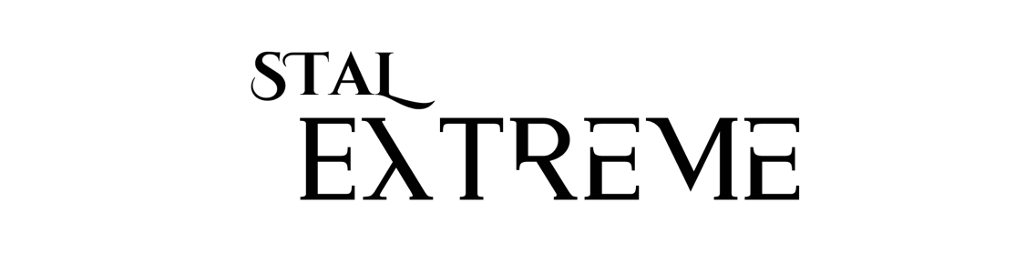

Extreme Friesian Stables and Stal Extreme
Dressage Symposium with Imke Schellekens-Bartels
Saturday and Sunday, April 19th and 20th, 2025
Stal Extreme - 2301 N. Mountain View Rd, Moscow, ID, 83843
Joe Michielli 509-768-3008 Extremefriesianstables@yahoo.com

SYMPOSIUM RIDER APPLICATION
Symposium rider applications will be accepted from December 1st – March 15th, 2025. There will be 10 horse/rider pairs selected to ride both days of the symposium. Selected rider/horse pairs must participate in both days. Riders may apply with more than one horse to participate—please submit one application for each horse. Selected pairs and reserves will be notified as soon as the selection process is completed, likely by March 31st , 2025. If selected, full payment must be received within three days of notification, or your ride will be given to another applicant.

Imke and Stal Extreme staff will be making the selections of the rider/horse pairs for the symposium. We expect there will be more applications than ride spots. Amateurs, JR/Young Riders, or Professionals with any breed of horse may apply. Imke and staff will select the rider/horse combinations based on their suitability for the symposium as a whole program. We are not looking for the perfect horse or rider, nor the most expensive horse. We are interested in coaching a variety of breeds and levels of horses, from Training through Grand Prix. Imke will be looking for riders who are ready and able to make requested corrections and perform exercises consistent with the level of riding designated on the rider application.

The symposium rider fee is $450 (per ride) and includes stabling and bedding for two
nights, a Friday rider’s dinner with Imke held at the Michielli’s, and lunch each day. Riders may bring one groom to the symposium. We will have a special bleacher section of seats for riders and their grooms to audit the rest of the symposium for free as part of your rider fee. Any other people accompanying the rider, including owners, must pay the full symposium audit fee.

If you cancel 2 weeks or more prior to the symposium, your fee will be refunded less a $100 processing charge. If you cancel less than 2 weeks prior to the symposium, your application fee will be applied toward auditing and no further refund will be given.

If selected, you agree to all of the requirements listed above, as well as the following additional requirements:
• Riders must ride the horse selected from the application.
• Horses and riders must be comfortable being instructed in front of a large audience in an indoor arena, as there
may be a large number of auditors in attendance along the sides of the arena.
• The rider must be ready, able, and willing to make the requested corrections and perform the exercises as directed by the clinician consistent with the level of riding designated on the application.
• Horses must not be bothered by amplified sound or audience activity.
• Horses must arrive at Stal Extreme on Friday, April 18th, by 3 p.m., and riders will have access to and are encouraged to use, the indoor arena during that time up until 5:00 p.m. to become acclimated to the arena and the sound system, chairs/tables, and other activity. After 5:00 p.m., the arena will be oﬀ limits.
• There will be Limited space available to park and leave your trailer at Stal Extreme for the weekend. Please Contact us to make arrangements for Trailer Parking in advance.
• On both clinic days, horses must be groomed for show quality, with manes braided, and all tack cleaned. White saddle pads and wraps should be used.
• Helmets are required and should be worn at all times while mounted.
• During the symposium, riders should wear white or light-colored gloves and britches; white, collared shirts; and shiny polished dressage boots. Long hair must be tied back and in a show presentation.
• All riders, owners, grooms, and auditors must sign a release form for Stal Extreme, and Imke Schellekens-Bartels
• Photographs taken by a professional photographer hired by Stal Extreme may take photos of auditors and demo riders, and these may be used for Stal Extreme, Extreme Equine Supplements, and or Extreme Friesian Stables social media. No other photography or videography is allowed.

SYMPOSIUM RIDER APPLICATION FORM
Rider’s Name: ____________________________________________________ Rider’s Age: _______
Rider’s Address: ____________________________________________________________________________
Rider’s Phone: ________________________________
Rider’s Email: ________________________________________
Rider’s USDF #:
___________________________________
Rider is a(n) (check one): Open Rider ____ Young Rider _____ Junior _____ Adult Amateur_____
Horse’s Name: _____________________________________________________________________
Horse’s USDF #: ___________________
Horse’s Breed: _______________________________________ Horse’s Age: _____________
Horse’s Current Showing Level: ________________________
We will review USDF show scores for applicants at USDF.org
Horse’s Current Schooling Level: _______________________
YouTube HTML Address of Video: ____________________________________________________________
Please provide a 3-5 minute video showing you and this horse at walk, trot, and canter demonstrating the current level of horse/rider. This will be reviewed by Imke along with the other information in this application as part of the selection process.
Attach a color photo of you and your horse in your application submission email that can be used in the Symposium program and social media if you are “selected to ride.”

Provide a short biography below about you and your horse (a short paragraph about each) that may be used in the Symposium program: __________________________________________________________________________________________________________________________________________________________________________________________________________________________________________________________________________________________________________________________________________________________________________________________________________________________________________________________________________________________________________________________________________________________________________________________________________________________________________________________________________________________________________________________________________________________________________________________________________________________________________________________________________________________________________________________________________________________________________________________________________________________________________________

Emergency Contact Name: _____________________________
Emergency Contact Phone: ______________________
Email your completed application and photo to extremefriesianstables@yahoo.com
Please put “2025 Imke Symposium” as the subject of your email.

Rider Signature: _______________________________________________ Date: ___________________

Guardian Signature: ____________________________________ Name: _________________________
Date: ______________________

